Class Exercise 5 – Object Oriented Metrics

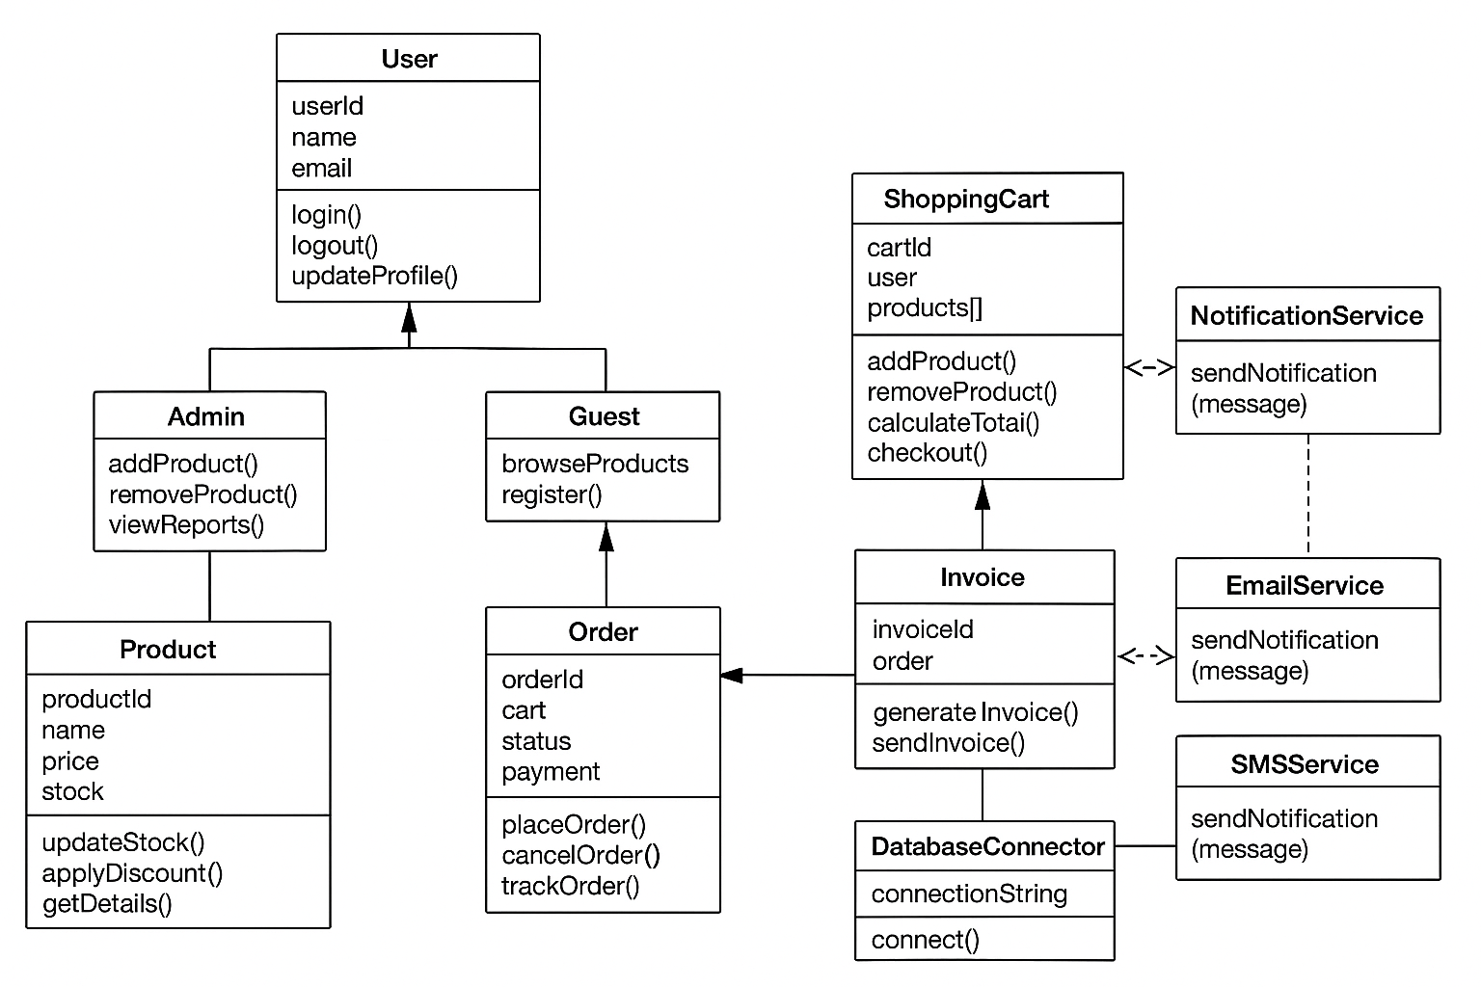

- Comment on which classes are large (many methods/attributes) and which are small.
- Identify classes with low cohesion (methods unrelated) vs high cohesion.
- Identify tightly coupled classes. Suggest decoupling strategies.
- Estimate which classes have the highest response set (due to calling many other classes).

